Deliverables

Volunteering Application
There’s a simple form to apply to be a Volunteer. You simply enter your name, email and address with an attached message of why you want to be a volunteer and that gets entered into a secure database where you, as an admin, can review applications and contact prospective volunteers.
The form is simple to use and nice to look at, with plenty of instructions and extra information to support applicants.
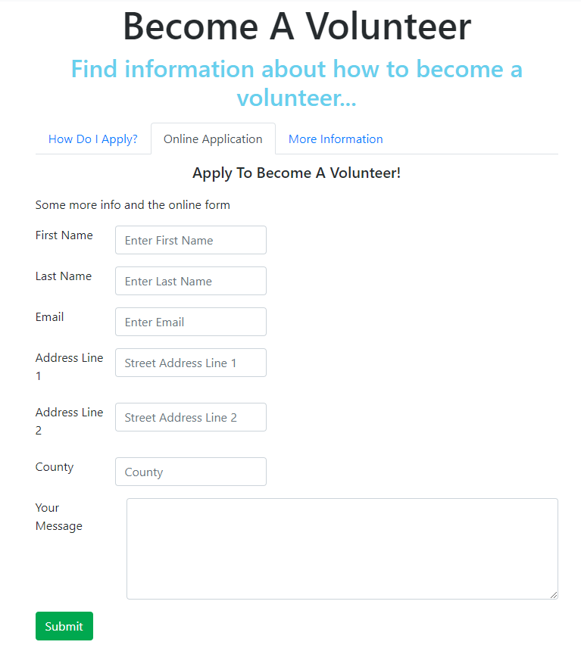

Carousel
Carousel implemented on the home page. Currently using stock images but will be able to edit using the admin page and show their own images and videos. Will be the front page of the website, so will look nice and attract visitors with a variety of different soothing media.
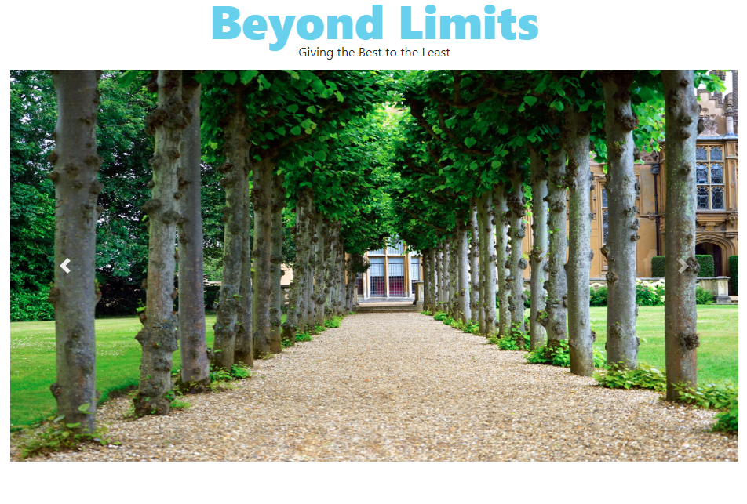

Admin Page
The admin page shows statistics and allows you to create and view events.
